**Bug on Page ‘my.bonify.de’:**

**Issues 7:** On ‘<https://my.bonify.de/register/personal>’ Page there are many text issues that are listed below:

7.a: Instead of ‘First Given Name’ it should be ‘First Name’.

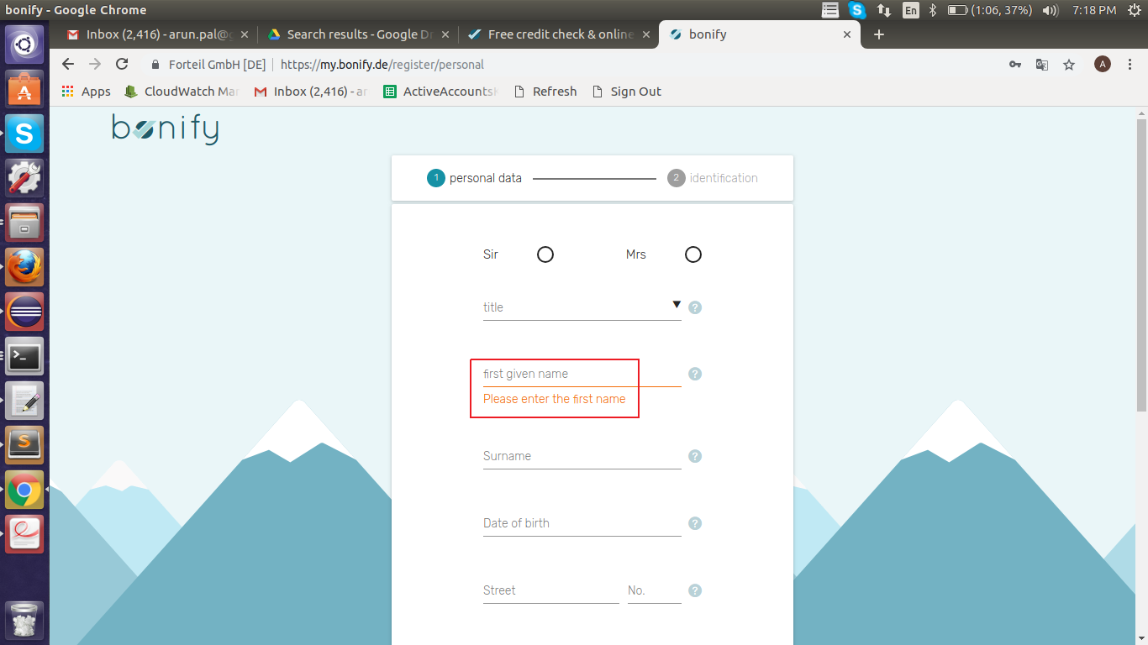

7.b: Instead of ‘Post Code’, it should be ‘Postal Code’.

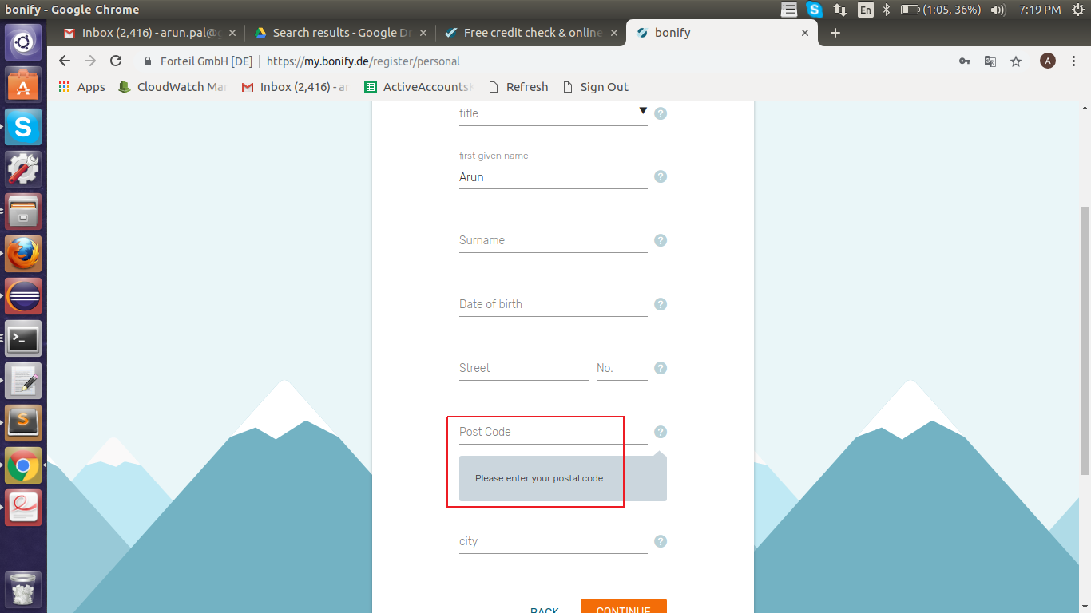

7.c: Instead of ‘Please enter the place of residence’ it should be ‘Please enter City’.

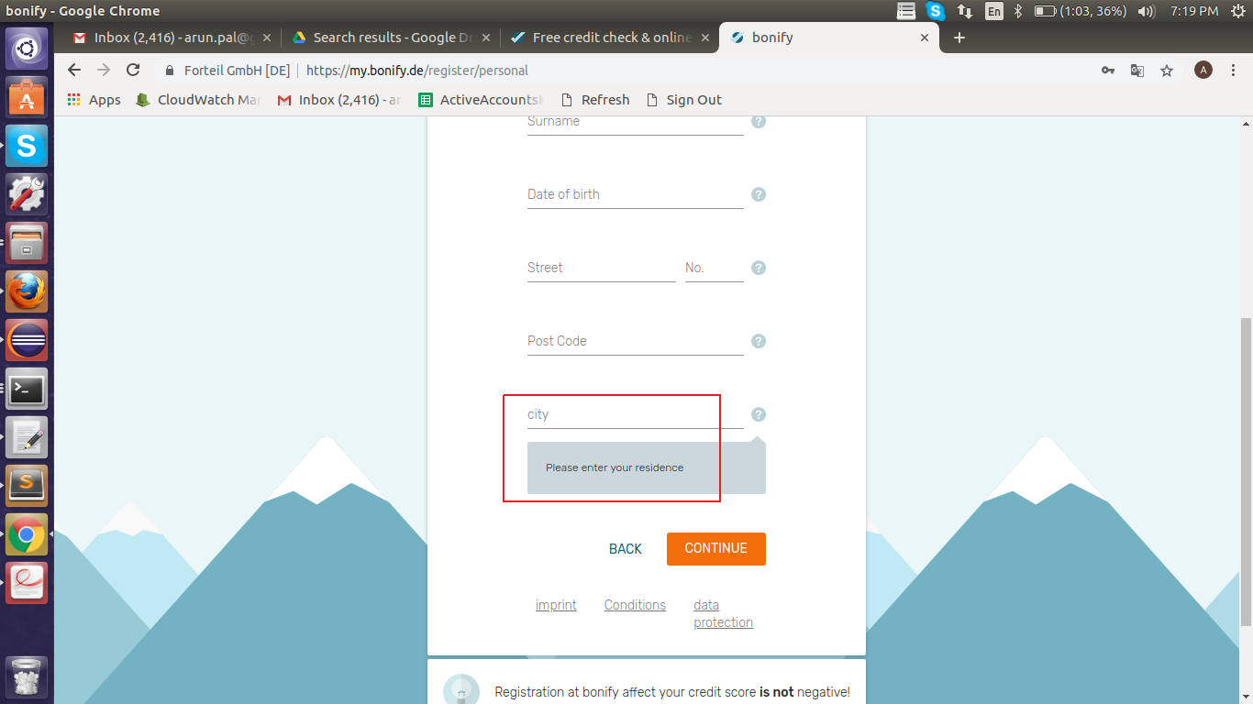

**Steps To Reproduce:**

1: Start Chrome Browser with url **‘**https://my.bonify.de/login?next=/**’.**

2: Click on ‘REGISTER’ Link.

3: Enter ‘Email’ and ‘Password’ and click on ‘REGISTER FOR FREE’.

4: Observe all the incorrect text for fields First Name, Post Code and City.

**Expected Result:** On ‘<https://my.bonify.de/register/personal>’ Page, text should display correctly

**Actual Result:** On ‘<https://my.bonify.de/register/personal>’ Page, text is not displaying correctly.

**Browser:** Chrome (Version 70)

**OS:** Ubuntu (16)

**Priority:** P3

**Assign To :** Developer.